Name: Class: Date:

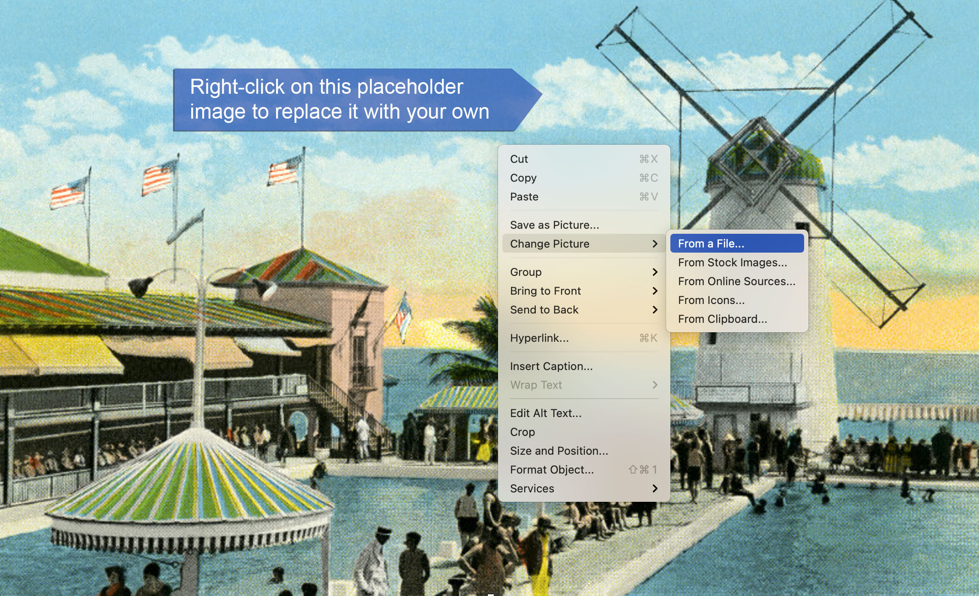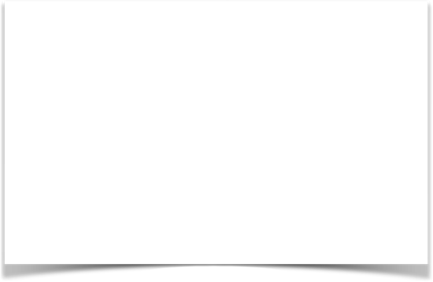

Post Card

FOR CORRESPONDENCE FOR ADDRESS ONLY

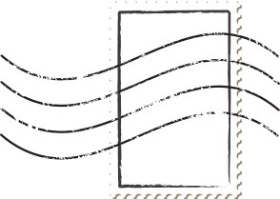

Type your message in this text box....

Type the address in this text box....